Worksheet 2.4

Student Name: Sahil Kaundal UID: 21BCS8197

Branch: CSE (Lateral Entry) Section/Group:20BCS-807_B Semester: 4th Date of Performance: 04/04/2022

Subject Name: SE Lab Subject Code: 20CSP-255

Q1.

1. Aim/Overview of the practical:

Design a class diagram for the following scenario

Library domain model

Purpose: Describe domain area for an Integrated Library System (ILS), also known as a Library Management System (LMS) - Library, Catalog, Book, Patron, Account.

Summary: Library Domain Model describes main classes and relationships which could be used during analysis phase to better understand domain area for ILS or LMS.

1. Task to be done/ Objective:



The purpose of class diagram is to model the static view of an application. Class diagrams are the only diagrams which can be directly mapped with object-oriented languages and thus widely used at the time of construction.

* Analysis and design of the static view of an application.
* Describe responsibilities of a system.
* Base for component and deployment diagrams.
* Forward and reverse engineering.

1. Requirement Analysis:

Software Requirement:

* Smart Draw
* Google Chrome

Hardware Requirement:

* Computer
* Windows 10
* Power Supply

1. Class Diagram:

The class diagram depicts a static view of an application. It represents the types of objects residing in the system and the relationships between them. A class consists of its objects, and also it may inherit from other classes. A class diagram is used to visualize, describe, document various different aspects of the system, and also construct executable software code.

It shows the attributes, classes, functions, and relationships to give an overview of the software system. It constitutes class names, attributes, and functions in a separate compartment that helps in software development. Since it is a collection of classes, interfaces, associations, collaborations, and constraints, it is termed as a structural diagram.

Library Domain Model describes main classes and relationships which could be used during analysis phase to better understand domain area for Integrated Library System (ILS), also known as a Library Management System (LMS).

Each physical library item - book, tape cassette, CD, DVD, etc. could have its own item number. To support it, the items may be barcoded. The purpose of barcoding is to provide a unique and scannable identifier that links the barcoded physical item to the electronic record in the catalog. Barcode must be physically attached to the item, and barcode number is entered into the corresponding field in the electronic item record.

Barcodes on library items could be replaced by RFID tags. The RFID tag can contain item's identifier, title, material type, etc. It is read by an RFID reader, without the need to open a book cover or CD/DVD case to scan it with barcode reader.

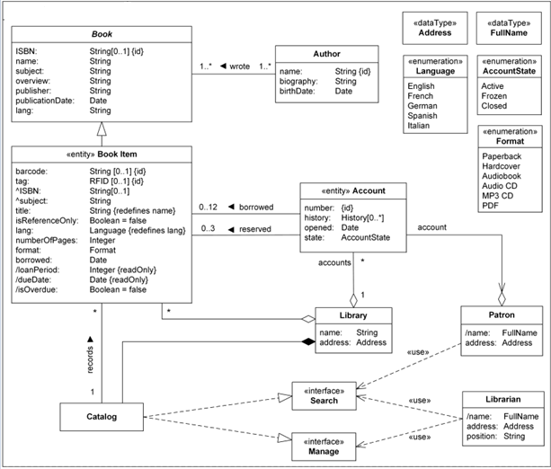

Library Domain Model.

Library book attributes ISBN and subject are [inherited](https://www.uml-diagrams.org/inherited-property.html) from Book and shown with prepended caret '^' symbol.

The title attribute explicitly [redefines](https://www.uml-diagrams.org/redefining-property.html) name. While type of the attributes is the same, name is different. The lang attribute is explicitly redefined with different type. Original type was free text String, while redefined attribute is more specific (e.g. enumerated) Language class. We used explicit redefinition in this case because attribute types String and Language are not related. Language is [enumeration](https://www.uml-diagrams.org/data-type.html#enumeration) type.

Library has some rules on what could be borrowed and what is for reference only. Rules are also defined on how many books could be borrowed by patrons and how many could be reserved.

Library book attributes loanPeriod, dueDate, and isOverdue are [derived](https://www.uml-diagrams.org/derived-property.html). Length of time a library book may be borrowed (loan period) depends on library policy and varies based on a kind of book and who is borrowing it. For example, in a university library undergraduates could borrow book for 30 days, graduate students for a quarter, and faculty staff for a year. In a public library normal loan period for a book could be 3 weeks, while it could be lowered to 2 weeks for new books. Book return due date will be calculated based on the borrow date and loan period. If due date is past the current date, isOverdue Boolean flag which is false by default will be set to true.

Library Catalog provides access for the library patrons and staff to all sources of information about library items, allows to search by a particular author, on a particular topic, or in a particular format, that the library has. It tells the user where materials meeting their specific needs can be found.

Q2.

1. Aim/Overview of the practical:

Design a class diagram for following scenario

Online shopping domain model

Purpose: Show some domain model for online shopping - Customer, Account, Shopping Cart, Product, Order, Payment.

Summary: Example of a UML class diagram representing online shopping domain. Each customer could have some web user identity. Web user could be in one of several states and could be linked to a shopping cart.

1. Task to be done/ Objective:



The purpose of class diagram is to model the static view of an application. Class diagrams are the only diagrams which can be directly mapped with object-oriented languages and thus widely used at the time of construction.

* Analysis and design of the static view of an application.
* Describe responsibilities of a system.
* Base for component and deployment diagrams.
* Forward and reverse engineering.

1. Requirement Analysis:

Software Requirement:

* Smart Draw
* Google Chrome

Hardware Requirement:

* Computer
* Windows 10
* Power Supply

1. Class Diagram:

The class diagram depicts a static view of an application. It represents the types of objects residing in the system and the relationships between them. A class consists of its objects, and also it may inherit from other classes. A class diagram is used to visualize, describe, document various different aspects of the system, and also construct executable software code.

It shows the attributes, classes, functions, and relationships to give an overview of the software system. It constitutes class names, attributes, and functions in a separate compartment that helps in software development. Since it is a collection of classes, interfaces, associations, collaborations, and constraints, it is termed as a structural diagram.

Online Shopping

The purpose of the diagram is to introduce some common terms, "dictionary" for online shopping - Customer, Web User, Account, Shopping Cart, Product, Order, Payment, etc. and relationships between. It could be used as a common ground between business analysts and software developers.

Each customer has unique id and is linked to exactly one **account**. Account owns shopping cart and orders. Customer could register as a web user to be able to buy items online. Customer is not required to be a web user because purchases could also be made by phone or by ordering from catalogues. Web user has login name which also serves as unique id. Web user could be in several states - new, active, temporary blocked, or banned, and be linked to a **shopping cart**. Shopping cart belongs to account.

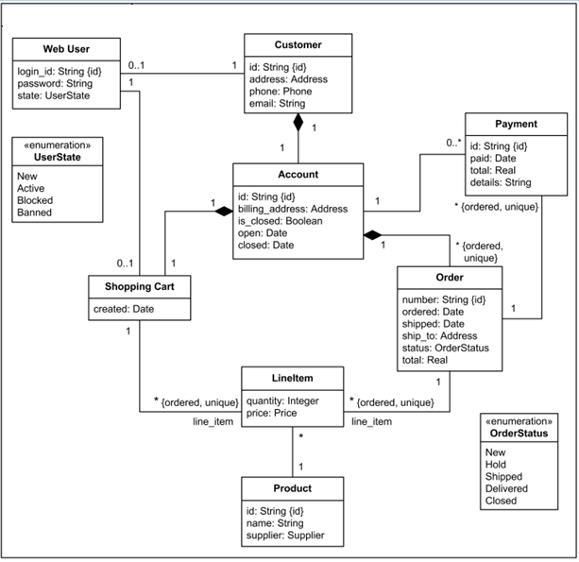

Account owns customer orders. Customer may have no orders. Customer orders are sorted and unique. Each order could refer to several **payments**, possibly none. Every payment has unique id and is related to exactly one account.

Each order has current order status. Both order and shopping cart have **line items** linked to a specific product. Each line item is related to exactly one product. A product could be associated to many line items or no item at all.

1. Result/Output/Writing Summary:

I have successfully done this practical.

Learning outcomes (What I have learnt):

1. Learned about Class Diagram.
2. Learned about Class Diagram of Online shopping domain model.
3. Learned about Class Diagram of Library domain model.

Evaluation Grid (To be created as per the SOP and Assessment guidelines by the faculty):



|  |  |  |  |
| --- | --- | --- | --- |
| Sr. No. | Parameters | Marks Obtained | Maximum Marks |
| 1. |  |  |  |
| 2. |  |  |  |
| 3. |  |  |  |
|  |  |  |  |